“Theodolite” Problem

In the diagram below, segment AB represents a person, with point A at eye level, and CD represents a tree.
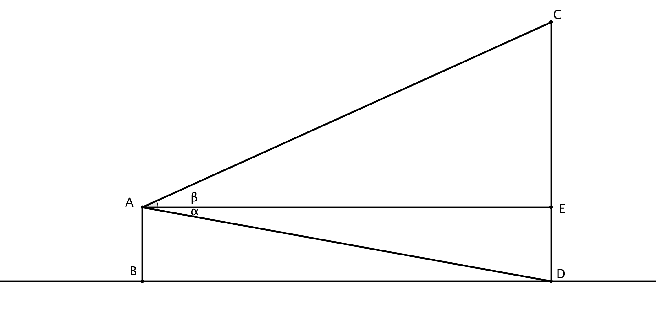
Assume that AB equals 5 feet, angle DAE has measure 10 degrees, and angle EAC has measure 15 degrees. Determine the distance of the base of the tree from the person, and the height of the tree.

