Introduction to WeBWorK for Students
- What is WeBWorK?
WeBWorK is a system developed at the University of Rochester that allows us to put homework problems on the web and allows you to submit your answers on the web. WeBWorK is currently used in over 300 colleges, universities and high schools.
WeBWorK is a grader, not a tutor. It will give you immediate feedback on your mastery of each topic. It may also give you hints. Research has shown that the use of WeBWorK has improved student success by an average of half a grade in College Algebra courses at some universities. WeBWorK requires that you have access to the internet, but you are not required to have access while working out a homework set — only for downloading the set and for submitting your answer
You may try each homework problem up to fifteen (15) times and, with each try, there is a message telling you whether the answer is correct or not. There is no penalty for submitting several incorrect answers to a problem before submitting the correct answer. This allows you to find your own errors and to understand the topic of the question better. The WeBWorK homework sets are individualized so that each student has a different version of each problem.
- How to use WeBWorK to do your homework
  - Find a computer with access to Firefox, Chrome, Internet Explorer, Safari or another browser. It can be either your own or one in any of the university computer labs. We have found it best to use Firefox in order to avoid random characters appearing in the formulas.
  - Open the browser and go to the main WeBWorK homepage. The address is: https://courses.webwork.maa.org/webwork2/uky-ma113
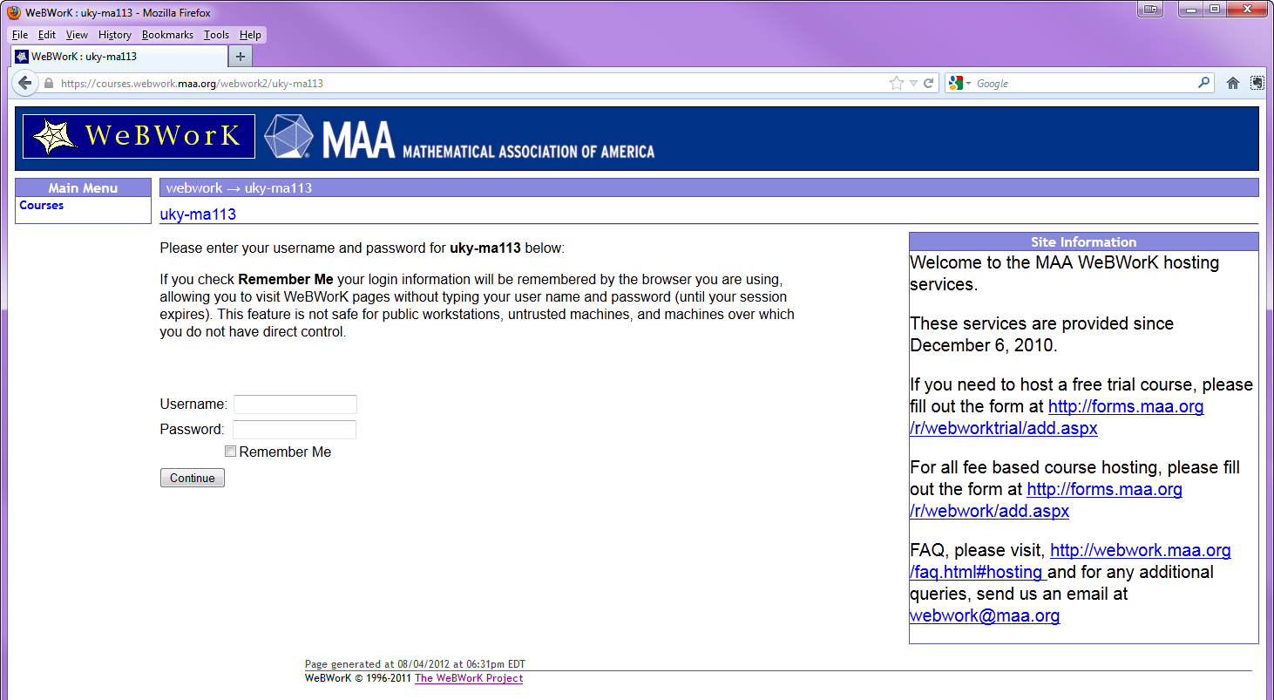
  - To log in, fill in your username (this is the same as your LinkBlue userid in ALL CAPS) and your password (this is initially your UKID number), and click on the Continue button: .
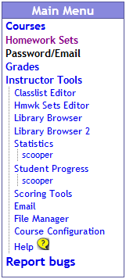
  - You should now be looking at a page headed by the course title and term that lists the homework sets that are available for you to work on. The first thing you should do is to change your password. Click on Password/Email in the Main Menu.
  - You will be presented with the following window in which you should change your password from the initial login password to something of your own making. Additionally, if you do not wish to receive all email through WeBWorK through your UK email account, you can enter a new email account in the Change Email Address. WARNING: All email will go to that email account. It must be an account that you access on a daily basis. Most communication about this course will be done through email. We suggest that you use your UK email account as all official UK announcements will be sent there.
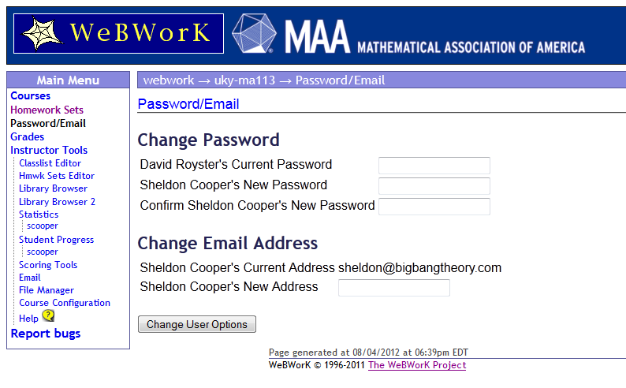
Sheldon Cooper’s Current Password
When you are done with your changes, click on Change User Options.
  - Click on Homework Sets in the Main Menu and you will be presented with a list of Homework Sets.
In the Status column, each set is marked as open, closed, or not yet open. If the set is open, that means that when you solve a problem, it will be counted towards your grade. If the set is closed, you can still solve problems and get your answers checked, but your results will not be recorded.
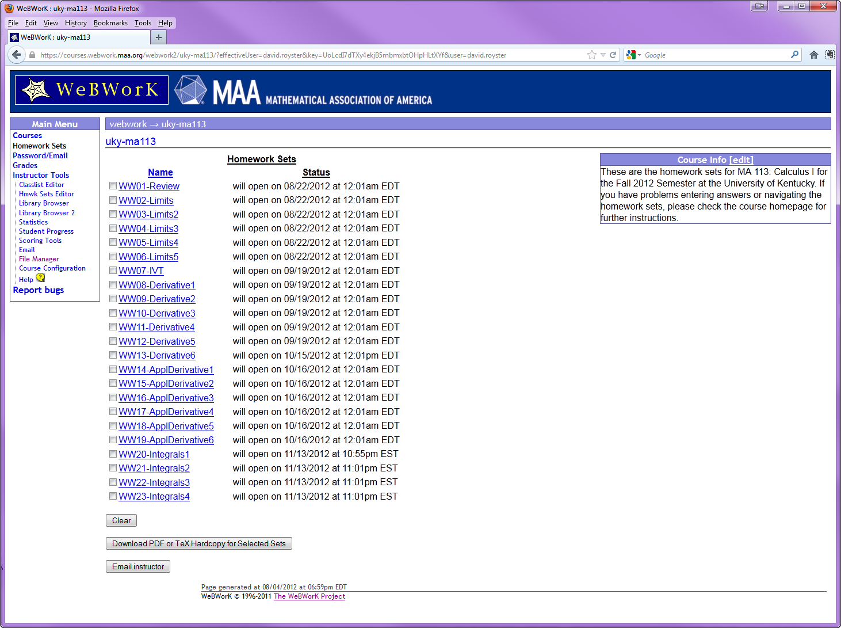
After the indication of whether the set is open or closed, there is additional information about the due date (if the set is open), or whether the answers are available (if the set is closed). When the answers are available, you have the option of looking at correct answers when viewing a problem.

  - After you have clicked on a homework set, you will see a page with a list of the problems in the set you chose. To view and/or answer a problem, click on that problem in the 'Problem Number' list.
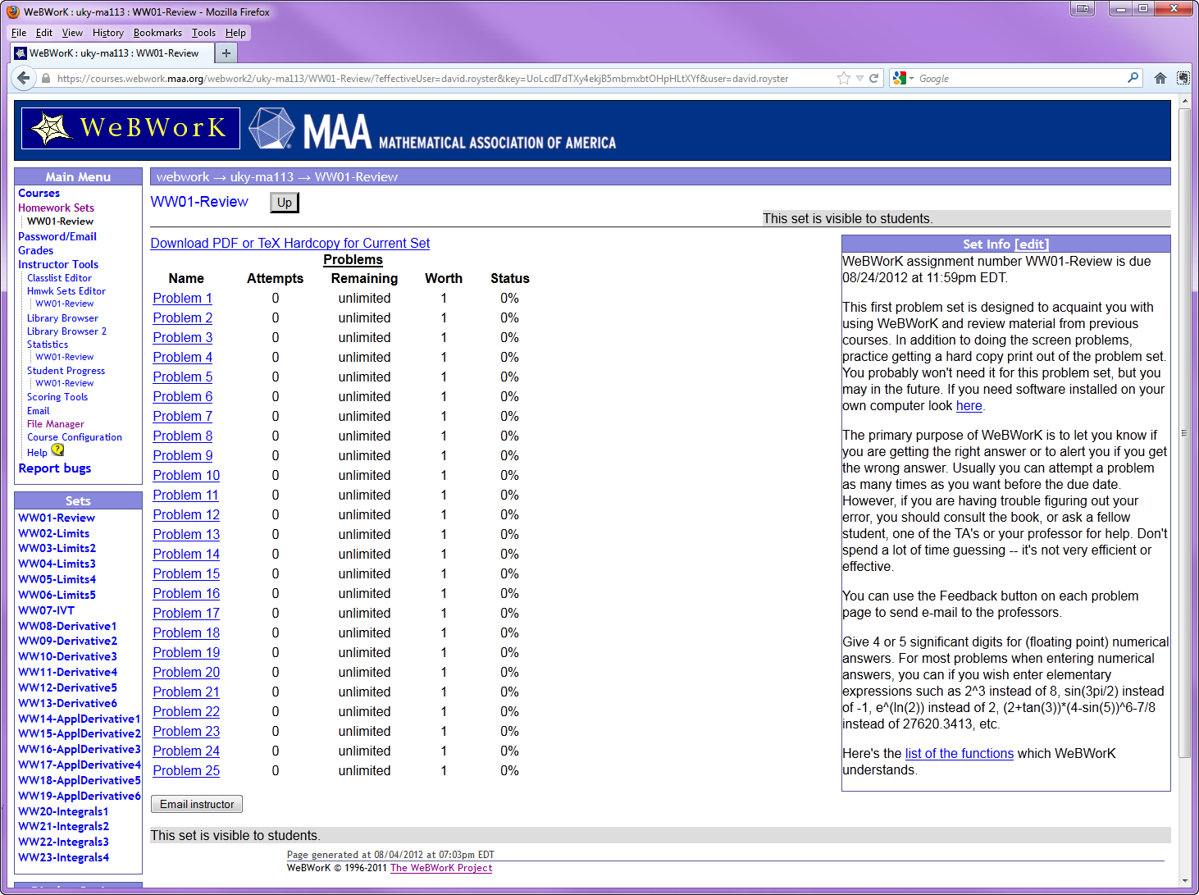
  - First generate a hardcopy of your homework set. You can do so as follows:
Click on Homework Sets in the Main Menu. To print out a particular set, click in the box next to that set in the Name column, and then click Download Hardcopy for Selected Sets. You will be taken to the Hardcopy Generator page. Check that the desired set is highlighted, and then click the Generate Hardcopy button at the bottom of the page. Wait for the server to generate the page, and then save it to your computer and print a copy. Your instructors cannot emphasize enough that you should always first download a hard copy of your Homework set and work it out by hand away from the computer, or at least think carefully about each of the problems on it. Working out a homework set in from your computer without previous preparation leads to guessing answers and that is not very efficient or effective. Studies show that this practice leads to poorer performance on exams.
  - Once you have finished working out the problems in your homework set, you can input your answers. Click on the name of the set (it is a hyper link) and you will see a page listing the problems in the set (middle columns) and other information, including due date and whatever the instructor wants to communicate to you (right column).
  - Once you click on a problem, you will see the text of the problem with boxes for your answers. After working out the problem on paper, enter your answers in the boxes and click on the Submit Answers button. You will want to save the paper on which you work out the problems, because this is part of what you will need to study for quizzes and exams.
When you submit an answer, you will be told immediately whether or not your answer is correct. If your answer is not correct, you may try again. After you have attempted a problem, you can use the buttons at the top of the page to go to the next problem or the previous problem, or to see the list of problems again. If you are working on a homework set that is already closed, you will have the option to see the correct answer. To see the correct answer, just check the box Show correct answers and click on the Check Answers button (you do not have to enter an answer to see the correct answer).
If your answer is marked incorrect by the computer and you are not sure what it has read is what you have entered, check the Answer Preview column that appears at the top of the page once you have submitted an answer. The computer shows you how it is interpreting your answer.
If you want to check the status of your problems (e.g. to double check that your answers have been recorded), use the Prob. List button at the top of the problem page to see the problem list page. The problem list page shows how much credit you have for each problem that you have attempted.
When you finished working, log out by clicking on Log Out at the top right corner of the page or towards the top of the left panel. All of your answers to date will be saved. You do not have to finish a homework set all in one sitting.
  - There are three links at the left of the page in the Main Menu that are available to you at all times during a WeBWorK session.
    - Homework sets takes you to the list of available sets (the page you saw immediately after you logged in).
    - Password/Email takes you to the page where you can reset your password and the email address used by WeBWorK to contact you.
    - Grades takes you to a summary of your grades for WeBWorK assignments.
    - Also available to you at all times is an Email instructor button, at the bottom of every WeBWorK page.

III. Important facts to know
- What do you do if you have problems with WeBWorK?
  - If you have a problem logging in, contact your instructor.
  - If you have a problem printing out a set, ask a consultant at one of the computer labs. If you don’t get sufficient help, contact your instructor.
  - If you have questions on specific homework problems or if you have comments about WeBWorK that you think can help us make WeBWorK better, click on the 'Email instructor' button on any of the pages of WeBWorK.
- If you are logged on to WeBWorK for longer that 30 minutes without any activity, you may be asked to log in again. This is a security measure. You can resume your work after you are logged back in. All your results from the last log in will be saved.

