SMART GRAPH WORKSHEET

- In the space below, sketch your bar graph you created using your candy. Be sure to label each axis and give your graph a title.

- Now let’s create the bar graph on the TI-73 using the same data.

- Let’s explore our data. What if I changed my data set? Lets say I switched with a neighbor 2 _________ for 5 __________. Sketch your bar graph in the space below. Then make the changes on the calculator.

- Identify some similarities and differences between your sketched bar graph and the bar graph you created on the TI-73.

- Now consider what occurred in step 3. Which method was easier to change? Why does this make a difference in our student’s education?

Lists on the TI-73

To Create User-Named Lists:
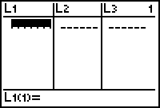
1: Depress the LIST key, found under the DEL key in top center.

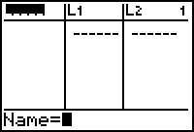
2: You can use L1, L2, L3, or any of the other available lists. You can also create your own named lists. To do this:
- Arrow up and highlight L1.
- Depress the 2nd key and the DEL key. This will insert an unnamed list. Before we can do anything, we must name this new list.
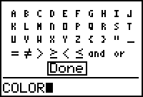
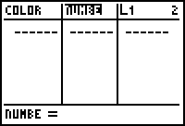
- To name our new list, depress the 2nd key and the MATH key. (TEXT) This will bring up the alphabet menu. By using the arrow keys and the ENTER key, type out your title. If you make a mistake, just hit the DEL key. When done, highlight Done and press ENTER.
- Press ENTER again and this will save your list. To add any additional lists, repeat these steps.

To enter the word names:
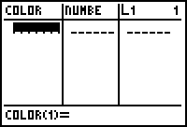
1) Using the arrow keys, move the cursor to the open space below
the list named COLOR. If you do not, the calculator will not
accept what you have done and will give an error message. To
correct, just go back into LIST, arrow and highlight the word
COLOR, and press clear.
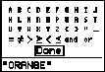
2) Select 2nd key and MATH key. (TEXT)

3) For the first color, you must enclose the color with “” marks so
that that the calculator knows you are entering a list of characters.

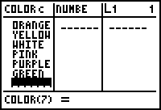
4) Type in the color name and press done. Hit enter and this saves
the color in the list.

5) Repeat with each additional color, except you do not need to put
quotation marks around the colors.

To enter number lists:
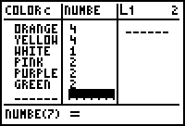
- Arrow over to NUMBE.

- Enter the number of each color and press enter after each number.

Graphing on the TI-73
Graphing your plots:
1) Press the 2nd key and the Y = key. (PLOT)

2) Choose Plot 1 by pressing ENTER. We can choose from
8 different graphs. In order from left to right:
Row 1: Scatter Plot, Line Graph, Pictograph, Bar Graphs.
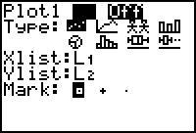
Row 2: Pie Graph, Histogram, Box Plot, Box Plot w/outliers.

To select the graph style you want, use the down arrow key
to move to Type and then use the left and right arrow keys to
move through the graphs. Use ENTER to select.

3) If we take a look at the Pictograph screen, we find we are
asked for a CategList and a Data List. The CategList is
our character list and can be inserted by first move cursor
down to CategList, then hit the 2nd key and the LIST key.
(STAT) Find COLOR and press ENTER. We will need to
do the same to enter NUMBR into the Data List spot. Scale
is how many our icon will represent. We can portray the
graph horizontally or vertically. We even have a wide
variety of icons to choose from.

4) Before we can graph, we need to turn the Plot on by
placing the cursor at the On position and pressing ENTER.

5) To explore the graph, press the TRACE key. You can use
the left and right arrow keys to explore the data.

6) If you want a different graph, just follow step 1 through 5.

7) With the Bar Graph, you can choose up to 3 Data Lists.
This is helpful if you want to compare different groups,
different peoples, or even different years or countries data.
The 1 2 3 in the bottom right corner, lets the calculator know
how many of the Data Lists you are using.

8) The Pie Graph, lets you graph the number or even the percent. The pictograph, bar graph and the pie graph are special features just for the TI-73. The numbers in the left hand corner when you are graphing the number side is the number that you typed into the list. But the numbers in the corner when you do the percent version are the percents of each color to the whole.

Probability on the TI-73

The TI-73 comes equipped with several probability functions that are helpful in the classroom. Press the MATH key and using the arrow keys, highlight PRB.

Here is the Probability Menu. We can generate random numbers; random integers, permutations, combinations, factorials and we can even flip multiple coins or roll dice (number cubes).

Rand will generate a collection of numbers between 0 and 1.
RandInt (low, high) will generate an integer between the lowest and the highest number you want.
nPr will generate the permutations as long as there is no repeats in numbers or letters.
nCr will generate combinations. To use nPr and nCr, you must first enter n, and then press the desired choice and then type r.
! will calculate a number n*(n-1)*(n-2)* . . . *1.
Coin(# of coins) will flip a coin(s). If a 0 appears you got tail and if a 1 appears you got a head.
Dice(# of dice) will roll six sided number cubes.

Texas Instruments has developed several applications that are located on APPS menu. One such application is Prob Sim.
Here you can explore several simulations and change their difficulty to match your grade level.
With this simulator, you can explore data beyond 10 or 20 times. There are graphics, stores in data lists so you can graph the data and ask questions about what they see. You can even make unfair coins and dice to explore what cheaters do.

