Soap Under the Sheets for RLS, Leg Cramps

Home Remedies
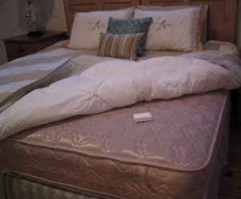
There is now a prescription drug (Requip) to treat RLS (restless leg syndrome). The only problem is that some people fall asleep during the day. This could be risky if they are behind the wheel. As far as we can tell, there are no side effects to putting soap under the bottom sheet.
Q. Several months ago I went to my neurologist for my yearly physical and told him about a problem I had with my legs "jumping" at night and waking me up. He gave me the technical name for it and wrote me a prescription for Mirapex.
I then told him I had read in your column about putting a bar of soap in the bed, so he told me to try the soap and fill the prescription if it didn't work. I still have the unfilled prescription sitting on my bathroom vanity. When we went on a trip to Yellowstone, I took my soap along and slept fine every night we were gone.
A. This home remedy mystifies us, but we have heard from many readers like you. The risk of unwrapping a fresh bar of soap and putting it under the bottom sheet where the legs will be is almost zero. The cost is far less than a prescription.
Positive responses from other readers experimenting with Ivory soap remedy:
“A while back I wrote to complain that the bar of soap under the bottom sheet quit working for my restless legs. (It was great at first.) Then I got to thinking, it worked before, so why not now? That bar of soap had been there for six months, so I replaced it. The result: no more restless legs. A few times that I had symptoms, I put my feet on the soap and the sensations went away in about two minutes.��?
“My husband was having severe leg cramps at night. Without telling him, I placed a soap bar under his sheets for two nights before he noticed. It worked! He’s had no more cramps. We still can't believe it!��?
““I have had severe leg cramps for years. When I read about putting a bar of soap in bed, I got a bar of Ivory and put it under the bottom sheet near my legs. It’s been a month since I did that, and I have not had one leg cramp.��?
Copyright (c) 1999 by Graedon Enterprises, Inc. From The People's Pharmacy Guide To Home And Herbal Remedies by Joe Graedon and Teresa Graedon. Reprinted by permission of St. Martin's Press, LLC.

