Download & Install TI Connect

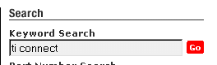Go to TI.com

Type TI Connect in the search
Click Go

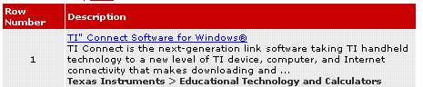

(TI connect should be the first link)

Scroll down the page
Click on

Go to English use the HTTP: link to download.

Save this download to a directory that you can identify. (AMSP folder)

Once the download is complete, click Open Folder.

Click on 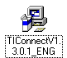 icon to install. Follow installation instructions.

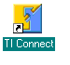You will be forced to restart to complete the installation.

After restart, there will be a TI connect icon will be on the desktop.

Plug in the calculator cable in the computer USB port.

Double click the TI Connect to launch the program.

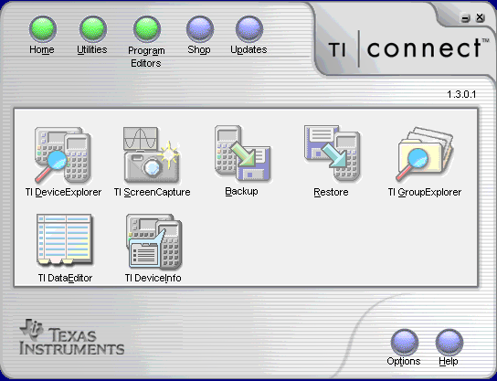

DeviceExplorer – Download calculator to computer

Most of the icons are self explanatory.

