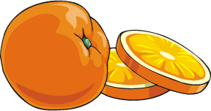

Citrus Circles

An Area Activity

OBJECTIVE: The student will construct a parallelogram from a circle to
discover the area formula for a circle.

NOTE: This activity requires student understanding of the area formula for a
parallelogram, and the radius and circumference of a circle.

MATERIALS
- Large juice oranges or grapefruit
- Plastic knives
- Paper plates

TEACHER PREPARATION
- Slice each orange / grapefruit through the center and cut several eighth inch slices avoiding the end sections of the fruit. Each piece of fruit should yield three or four slices.

ACTIVITY DESCRIPTION
1. Give each pair of students a paper plate, a plastic knife, and a fruit slice.
- Ask the students what the rind of the fruit slice represents. (The circumference of the circular slice.) Ask the students what the edge of one of the sections of the fruit slice represents. (The radius of the circular slice.)
- Demonstrate cutting a circular fruit slice into congruent semi-circles.
- Ask the students what the rind of the semi-circles represents. ( One half the circumference of the circular slice.) Recalling that the circumference of a circle with radius r is C = 2πr, ask the students what the length of the semi-circle would be. ( ½ C = ½(2πr) = πr)
- Tell the students to separate the sections of both halves of the fruit slice and fit the slices together by alternating sections of the halves as pictured below.

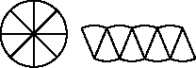

- Ask the students what the shape looks like. (A parallelogram.)
- Recalling the area formula for a parallelogram, which is A = bh, ask the students to try to determine a formula for the area of the fruit slice based on their answers to the questions about what the rind of the slice and the edge of a segment represented. (The students will need to determine that the base of this particular parallelogram is ½C (the circumference of the circle) and the height is the radius of the circle. Therefore the area is A = (½C)r; but another formula for C=2π r, so A = πr² )
- If the students only get as far as A = (½C)r, the teacher will lead the class to the final formula by asking questions. (What is the formula for the circumference? Can we replace that in this formula? Why or why not?)

MODIFICATION: This activity can also be done using circles that are subdivided into congruent sectors. The students cut out the sectors and fit them together alternating the sectors as depicted below.

