Adding the Odds

- Use snap cubes or tiles to build L-shapes to represent the first six consecutive odd integers.
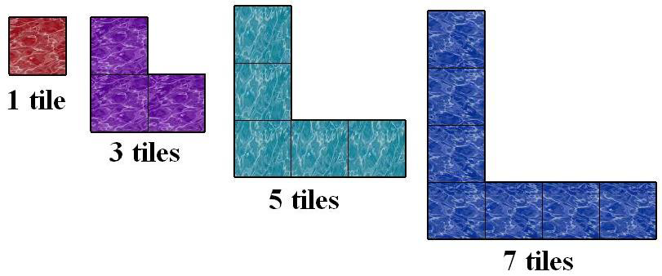

- What algebraic expression represents the number of cubes in the nth odd number?

- Use the first two odd number L’s to form a square. This square models the sum of the first two odd integers, 1+3.

- What are the dimensions of this square?

- Continue to nest the L-shaped models to show the squares that represent the sums of the odd integers and complete the chart below:

Addition Problem | How many odd integers? | Dimensions of the Square | Sum
1 | 1 | 1 x 1 | 1
1 + 3 | 2 | 2 x 2 | 4
1 + 3 + 5
1 + 3 + 5 + 7
1 + 3 + 5 + 7 + 9
1 + 3 + 5 + 7 + 9
1 + 3 + 5 + 7 + 9 + 11
.  .  . | .  .  . | .  .  . | .  .  .
The first n integers | n

- What algebraic expression represents the sum of the first n odd integers?

- Use this expression to find the sum of the first 85 odd integers?

