Making Stairs Count

Part I (Work in Pairs)

- Use the snap cubes or tiles to build a 1-step, 2-step, 3-step up to a 6-step staircase as shown below:
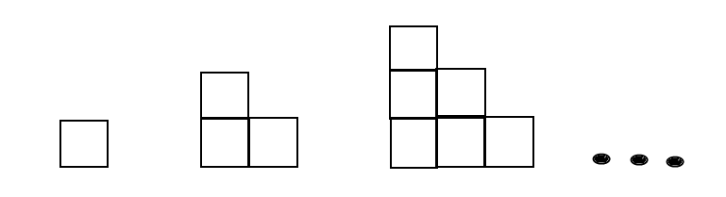

- These steps can be used to model the sum of consecutive integers. For example, the 3-step represents 1 + 2 + 3.

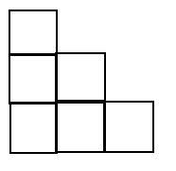
1

2 1 + 2 + 3 = 6

3

- Complete the columns B and C of the table below.

A | B | C | D
Number of Steps | Addition Problem | Number of Cubes
1

2

3 | 1+2+3 | 6
4

5

6

Part II

- Join another pair so that you have two sets of stair step models to complete Part II.
- Combine the two stair steps of the same size to form a rectangle. Observe the dimensions of the rectangle. For example, the rectangle formed by the 3-step staircase has dimensions 3 by 4.

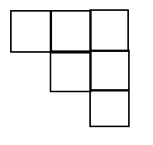
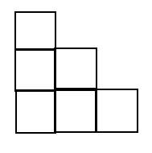
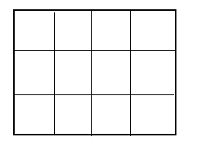

- Add column D labeled “Dimensions of Rectangle” to the table above. Complete column D. Be sure to write the shorter dimension first.

- If you had a stair step with 50 steps, what would be the dimension of the rectangle?

- How many cubes would there be in the rectangle? _________________

- How many cubes would there be in one of the stair steps? _____________

- What is the relationship between the number of cubes in one stair step and the number of cubes in a rectangle?

- Complete columns A—D in the table above for a 50-step staircase.

- Complete columns A—D in the table above for a 75-step staircase.

- Generalize the rule by completing the table for the n-step staircase.

- Write the algebraic expression used to find the sum of the first n consecutive integers:
1 + 2 + 3 +…. + n = ______________

