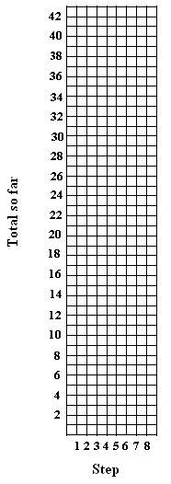
Tile Pattern Template

Growing Tile Pattern

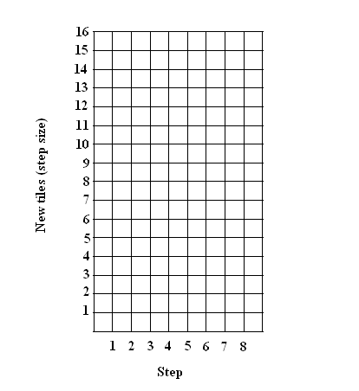

Step Number | New tiles (step size) | Total so far
1
2
3
4
5
6
7
8

