Middle School Math
And
Technology

2004 T³ International Conference
New Orleans, Louisiana
March 12-14, 2004

Eurice J. Dawley
^{Norview Middle School}
^{Norfolk, Virginia}

^{ejdawley@cs.com}
Exploring Middle Grades Mathematics
Objective:

Students will explore, investigate, and confirm basic mathematics concepts and properties using the TI-73 calculator. Students will discuss. Write to confirm and reflect upon their findings to optimize and reinforce their developing understanding.

Materials:

TI-73 calculator
Display Boards
Counters

Number Sense Topics

Order of Operations

Give students several expressions to model and to evaluate. Ask them to write down the steps and the answers. Discuss. Review models. Use the calculator to examine the expressions.
Examples:

2 + 3 · 2

On the calculator, type in the expression and press the [ENTER] key.
Have students to compare their answers to the value shown on the home screen. Discuss and ask questions to direct students’ thinking on the order the operations were executed. Students will record their findings.
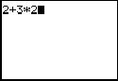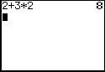

Build on the expression. For example, try

2³ + 3 · 2

On the calculator, type 2 press [MATH], scroll down to 3, press: [ENTER], [+] 3 [X] 2. Again, have students to model and discuss expected result. Now, press the [ENTER] key. Have students examine and discuss the order used to evaluate the expression to get the outcome displayed on the screen. Comparing their answers to the value shown on the home screen, students will record their conclusions from the investigation and discussion.

2 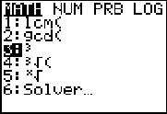  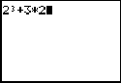 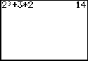

12 – 3(2³ - 3 · 2)

On the calculator, type 12 [-] 3 [(] 2 press [MATH], scroll down to 3, press: [ENTER] [-] 3 [X] 2 [)]. Again, have students discuss the model and expected result. Now, press [ENTER]. Have students compare their answers to the value shown on the home screen, and verify the steps.

Have students summarize results and compare to what fits in with the ‘Order of Operations’.

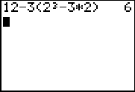

Properties

Use the TEXT menu or CATALOG to activate the ‘Boolean Operators’ to test the validity of ‘properties of real numbers’.

Commutative properties:

Show
3 + 8 = 8 + 3 and 3 · 8 = 8 · 3 are true statements.

On the home screen, type 3 [+] 8 [2nd] [MATH] to view the TEXT screen. Cursor to the ‘=’sign, press [ENTER].

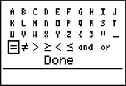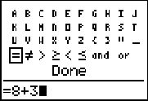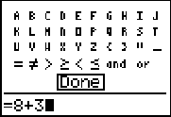

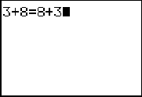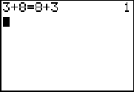

You may finish the equation while here (type 8 + 3), then cursor to ‘DONE’ press [ENTER] (this pastes the expression to finish the equation on the home screen). Press [ENTER] again. ‘1’ means the statement is true, ‘0’ means it is not true. Next, you show the commutative property of multiplication for the equation above.

Distributive Property Show
5(2 + 3a) = 5 · 2 + 5 · 3a,
and 5(2 + 3a) = 10 + 15a

On the home screen, type 5 [(] 2 [+] 3, press: [TEXT], select ‘A’, press: [ENTER] [)], scroll to ‘=’, [ENTER], 5[X] 2 [+] 5 [X] 3, scroll to ‘A’ press [ENTER], now cursor to ‘DONE’ press [ENTER] (This pastes the expression to finish the equation on the home screen). Press [ENTER] again. ‘1’ means the statement is true.
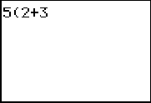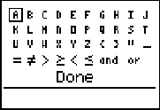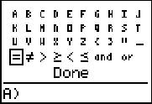

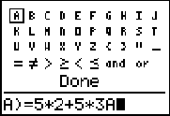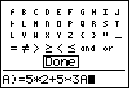

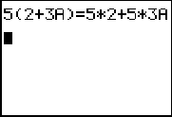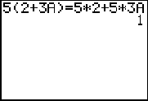

Evaluating Expressions

Let’s evaluate 15- 3(4a + 3) +2, for a = 3.

From the ‘home screen’, type 3 [STO], [TEXT], ‘A’, move to ‘DONE’, press [ENTER], [ENTER].

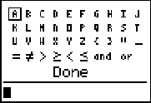

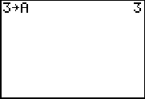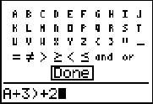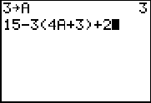

Now type in the expression 15 [-] 3 [(] 4 [TEXT] A [+] 3 [)] [+] 2, move to DONE, [ENTER], [ENTER].

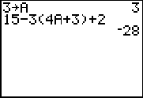
Again, have students to investigate the order of operations performed to arrive at the result. After testing their conclusions and identifying the pattern of steps observed in each of the problems, students will define their rules for ‘order of operations’.

Analyzing Data

Box and Whiskers Plot

Select a topic to explore that will be relevant to your students. Collect the data and enter into the LIST. Example: the total amount of change each of 9 students had in his/her pocket is 17¢, 25¢ , 87¢ , 131¢ , 75¢ , 0¢ ,25¢ ,75¢ and 9¢ . Enter this data in list 1 (L1). After students identify the measures of central tendency, range, extremes and quartile marks, use the CALC feature under [STAT] to perform a 1-Var Stats analysis on the data set. Press [ENTER], [ENTER]

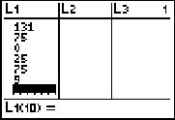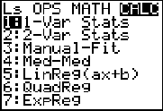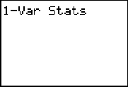

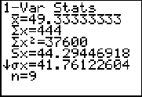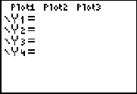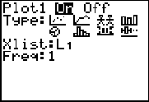

Now, make sure the Y= editor in clear. Turn on only one plot. Select the box and whisker plot. Xlist should be L₁. Ask questions of the students to identify the window settings or use the ZOOM STAT command to set the window range. Go to 7, press [ENTER]. Press [TRACE] and the left and right cursor keys to view the characteristics of the plot.

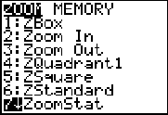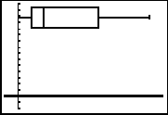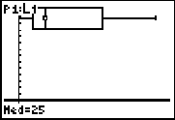

Solving Equations
Solving Linear Equations
Using the TI-73 Calculator

Solve 5x + 3 = 33

Method 1. Tracing in an Integer Window
Enter and Graph Y₁ =5x + 3
Use the TRACE key in an INTEGER window (ZOOM 0) to see the x-value for
Y= 33.

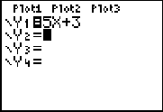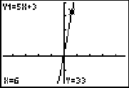

Method 2. Using Tables
Enter and Graph Y₁ =5x + 3
Use the TABLE menu, zoom in by changing the table set until Y = 33. The
x-value is the solution.

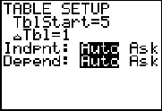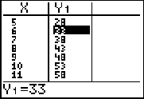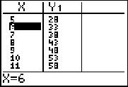

Method 3: Finding the Point(s) of Intersection Using Multi-Graphs
Enter and Graph Y₁ =5x + 3
Y₂ =33
Find the intersection by tracing in an integer window. When necessary, move from Y₁ to Y₂ using the up or down cursor. The x-value is the solution

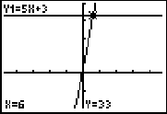

Method 4: Using the X-Intercept (Zeros)
Enter and Graph Y₁ =5x – 30

[From 5x + 3 = 33, get 5x – 30 = 0]. Trace until the y-value is zero. The corresponding x-value is the solution.

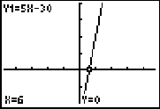

Method 5: Using Boolean Operators
Enter and Graph Y₁ =5x + 3= 33
(enter the = from the catalog or TEXT menu)
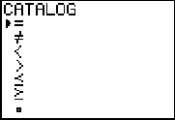

Use of the ‘=’ in the equation activates the BOOLEAN OPERATORS using Y=1 for true and Y=0 for false. The dot on the graph is the X-value for which Y is true and it is the solution for 5x + 3 = 33.

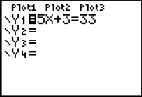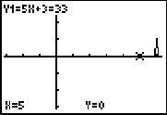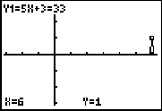

With all these activities, it is important to have students explore, discuss and write about their findings and reactions to their findings as they endeavor to make connections that lead to life-long learning. Questioning and writing are key components that compliment the use of technology as a teaching tool.

