Open Response:
Fourteen students read the book Gulliver’s Travels. In the book, the Lilliputians said they could make clothes for Gulliver by taking one measurement, the length around his thumb. They claimed that:
- the distance around Gulliver’s wrist would be twice the distance around his thumb.
- the distance around Gulliver’s neck would be twice the distance around his wrist.
- the distance around Gulliver’s waist would be twice the distance around his neck.

The students wondered whether this doubling relationship would be true for them too. They measured the distance around their thumbs and their wrists in centimeters, then graphed the pairs of numbers on a coordinate graph. They drew a line connecting the p9oints that represented wrist measurements that were twice thumb measurements.

- How many students’ measurements fir the Lilliputian rule that twice the distance around the thumb equals the distance around the wrist?
- How many students’ wrist measurements are less than twice their thumb measurements?
- The point for Jeri’s thumb and wrist measurements is above the line. If the cuffs of a shirt are twice the measurement around Jeri’s thumb, how will the cuffs of the shirt fit her?
- The point for Rubin’s thumb and wrist measurements is below the line. If the cuffs of a shirt are twice the measurement around Rubin’s thumb, how will the cuffs of the shirt fit him?
- How would you summarize the Lilliputian rule, in terms of its accuracy?\

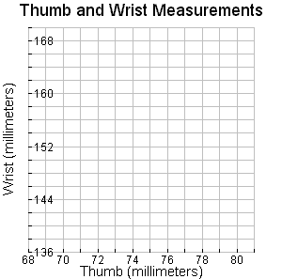

Rubric: All work must be shown for anything to be considered "correct"
- 10 points: All five parts correct with work shown
- 8 points: Four parts correct with work shown
- 6 points: Three parts correct with work shown
- 4 points: Two parts correct with work shown
- 2 points: At least one part correct with work shown
- 0 points: No parts attempted or correct

