Analyzing and Displaying Data on the Graphing Calculator

Creating lists
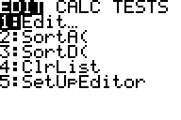
- Press the STAT key. Your screen should look like this.

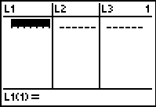
- Choose Option 1:Edit by hitting either ENTER or the number 1. Your screen should now look like this one.

- Use your arrow keys to move your cursor up so that it is highlighting L1.
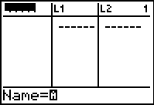

- Press the yellow 2nd key once and then press the DEL (delete) key. This should insert an empty list.

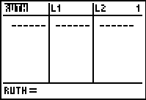
- Notice the cursor next to Name= at the bottom of the screen is flashing A. This means that the calculator is on Alpha-Lock…meaning you can now type using the green letters you see above many of the keys. Type RUTH and press enter.
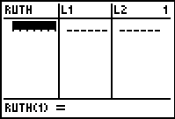
- Use your arrow keys to move the cursor down… off the name of the list and into the actual list itself.

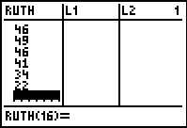
- Below is listed the number of homeruns that Babe Ruth hit in each of his 15 years with the New York Yankees from 1920-1934. Enter this data into your list by typing each number then pressing ENTER until all of the numbers are entered.

54 59 35 41 46 25 47 60 54 46 49 46 41 34 22

*** Some special features . . .
- To clear data from a list: Arrow up onto the name of the list. Press CLEAR. It will look like nothing happens. Arrow back down into the list, though, and the data should be gone. Once you've done this, this data CANNOT be retrieved.
- Should you accidentally delete a list and you want to get it back: Arrow up onto the name of any list. Press 2nd DEL for Insert. Rather than type a new list name, press 2nd STAT for the list menu, scroll until you find the list you deleted, and press ENTER. Press ENTER a final time now, and the data should reappear.
SORTING A LIST (this could help you in finding the median)

- From your home screen, press STAT.
- Select Option 2:SortA if you want to sort in ascending order(least to greatest). Select option 3:SortD if you want to sort in descending order (greatest to least).
- Press 2nd STAT for the list menu.
- Arrow down to the list you want to sort. Press ENTER to select it.
- Press ENTER. Your screen should now say "Done."
- Press STAT and then 1:Edit to check if your list is indeed sorted.
- Now try sorting your RUTH list by using the Option 2:SortA function. What is the 3rd number down in the list after you have sorted it? ________

CALCULATING MEAN
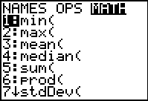
- Press 2nd STAT for the List Menu.
- Arrow over to MATH (on the top).
- Select Option 3: Mean
- Press 2nd STAT again for the List menu.
- Arrow down to the list for which you want to find the mean. Press ENTER to select it.
- Press ENTER.
- What is the mean of your RUTH list? _______

CALCULATING MEDIAN (this could help you even more in finding the median)

1. Press 2nd STAT for the List Menu.
- Arrow over to MATH (on the top).
- Select Option 3: Median
- Press 2nd STAT again for the List menu.
- Arrow down to the list for which you want to find the mean. Press ENTER to select it.
- Press ENTER.
- What is the median of your RUTH list? ________

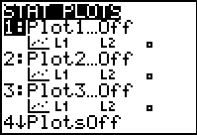
CREATING BOXPLOTS

- Press 2nd Y= for the STAT PLOT menu.

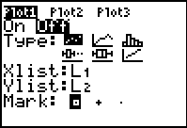
- Press ENTER or press the number 1 to select Plot1. Your screen should now look like this:

- Press ENTER again to turn the plot ON.
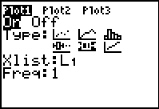
- Arrow down to TYPE. Using your right arrow key, arrow over until you get to the box & whiskers plot (it is the 5th graph, the 2nd one on the bottom row). Press ENTER. Your screen should now look like this.

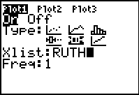
- Arrow down to "Xlist." Press 2nd STAT for the List menu. Arrow down until you find your RUTH list. Press ENTER to select it. Your screen should now look like this:

- Make sure the frequency (FREQ) is set to 1.

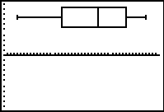
- You will now need to set an appropriate viewing window in order to see our plot. The calculator has the ability to set the window automatically based on your data. Press the ZOOM key on the top row. Now press the number 9. YOU SHOULD NOW SEE YOUR BOXPLOT!!!!

- Press TRACE (on the top row) and use your arrow keys to see the Five Number summary. Fill in those values below:

MIN (minimum value in the list):
Q1 (first quartile…the median of the lower half of the data):
MED(median)
Q3 (third quartile…the median of the upper half of the data):
MAX (maximum value in the list):

