Capturing Screens

Pressing the “Print Screen” key on your keyboard captures the entire screen on your computer.

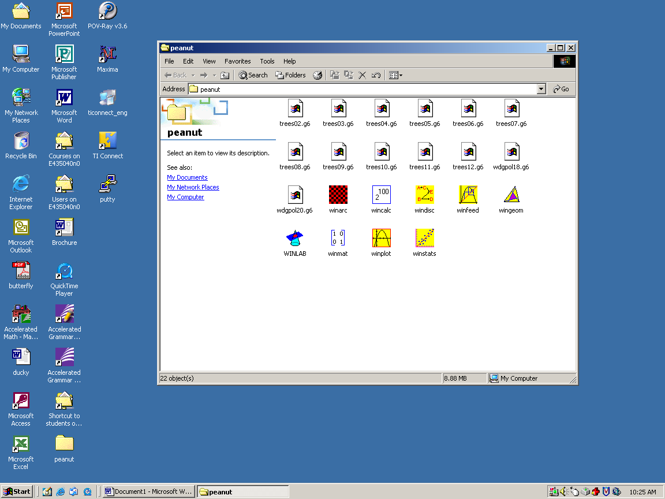

Pressing the CTRL and ALT keys simultaneous then pressing the “Print Screen” key will capture a picture of the active window.

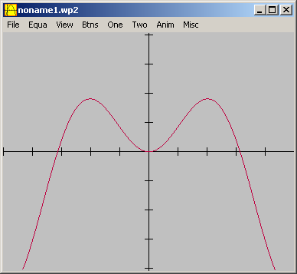

Pressing the left mouse key while simultaneously pressing the CTRL, ALT, PRINT SCREEN keys (respectively) will capture the active windows and any sub menu windows.

