Graphing inequalities on the TI-84 Plus

- Go to Apps-Inequalz

NOTE: Once you have started this program it will be on until you quit it. The window below will show up if you have already accessed this program.
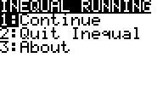

- Once you are in the program you will see a screen like this one:
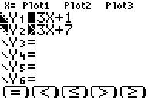

Now you have the options of inequalities! To access them you must use the ALPHA button. Notice as you change the inequalities there is a little picture on the left that will change with your selection.

- Graphing these inequalities is almost exactly like you would if you were to graph normally. The buttons across the top i.e. Y=, Window, ZOOM, Trace and Graph will function the same. Go ahead and investigate this.

- Here is an example of what the graph may look like (depending on your entries):
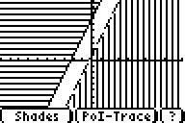

Here you can see that you have another menu. To access this menu you also need to use the ALPHA button. The Shades option is on the below/left and the PoI-Trace is on the below/right.
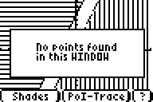
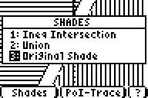
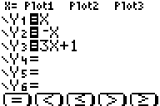
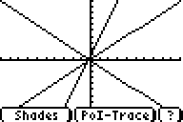
The reason why the window on the right says no points found in this window is due the fact that the lines do not intersect. We need to have points of intersection to use this. (I.e. Po stands for points, I stands for intersection and Trace stands for … Trace ☺) Here is another example:

Here is an example of the above with inequalities:
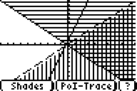
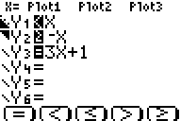

If you choose ALPHA-PoI-Trace you will see the following:
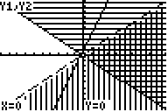
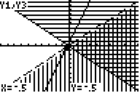

Now you will see where the lines intersect! Here we have two intersection points, which are located at the bottom of the screen. In the upper left-hand corner you can see what lines the intersection point corresponds to.

- Now that we have an idea of how to graph the inequalities you can start to explore the details. For example lets go back to the Shades option. Now here we can see three options: Inequality intersection, union and original shade. We go back to the previous graph and then select Inequality intersection and also Union.

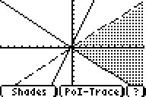
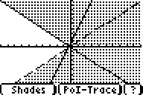

- Another minor detail is located in the WINDOW button at the top. Here we have an option of changing the ShadeRes. Here for simplification purposes we look just Y₁ and change the ShadeRes from 3 to 5 to 7.

