Making Lists, ScatterPlots, and Linear Regressions

Getting your calculator ready:
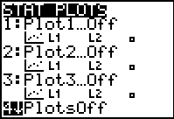
- On the calculator, go to the Y= screen and delete any equations listed by hitting the DEL key

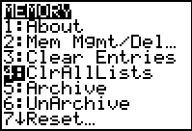
- Press 2nd Y= (for STAT PLOT), then press 4 and ENTER to turn all stat plots off.

- On the calculator, Press 2nd, + (for MEM), then press number 4 and press ENTER to clear all lists.

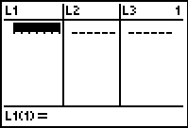
Entering Data into Lists:
1. Press STAT, then ENTER, to edit lists. Your screen should now look like this:

2. Now enter your data for x-values in L₁ and your y-values in L₂.
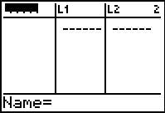
If you would like to name your lists something specific:
1.Press the arrow up key, then press 2nd DEL (for insert), and your screen should now look like this:

2.The calculator will automatically be on alpha-lock, so type the name for your list and press enter.
3.Press insert again (2nd, DEL), and now type the name for your other list.
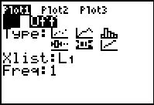
Making a Scatterplot:
1. Press 2nd, Y= (to get to STAT PLOT) and then press ENTER. Your screen should now look like this:

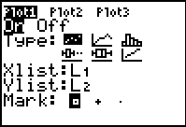
2. Arrow down to ON and press ENTER to turn this plot on.

3. Arrow down to TYPE and then press ENTER to select the scatterplot. If you prefer to have a line graph (where the scattered points are connected by individual lines, then choose the one next to the scatterplot).

- Arrow down to Xlist and then press 2nd STAT (for List). Arrow down to the list or press the number of the list where you have entered your data and press ENTER. The default list will be L₁, so if that is where you entered your data then just leave this as is.

- Your cursor should now be on Ylist. Press 2nd STAT (for List) again and arrow down or press the number of the list where you entered your y-values and press ENTER. Again, the default list will be L₂ so if this is where you entered your data, then leave this alone.
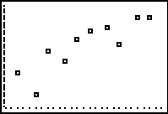
- Press the GRAPH button, then press ZOOM, then press the number 9, then press ENTER. Your screen should now look something like this (yours will vary depending on your data):

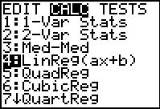
Creating the Line of Best Fit:
1. Press the 2nd MODE to QUIT your graph, then press the STAT key, now arrow over to CALC, arrow down to LinReg or press 4, and then press ENTER.

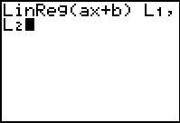
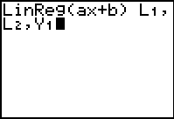
2. Now press 2nd, STAT (for LIST) and choose the list where your x-values are, press the comma key (above the 7), then press 2nd, STAT (for LIST) and choose the list where your y-values are. If your data is in a numbered list (L₁..L₆) then you can choose 2nd and the number of the list instead of having to select it from the list. Your screen should now look like this:

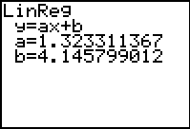
3. Press comma "," again, now press the VARS key (under the arrows). Arrow over to Y-VARS, and press enter for FUNCTION. Choose 1:Y₁ by pressing ENTER. Press enter again and your screen should look like this but with different numbers: (a, is your slope, and b is your y-intercept)

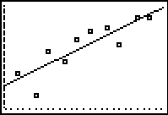
4. If you press Y= now, an equation for the line of best fit should appear in Y₁=.

5. Press GRAPH to see your scatterplot with your line of best fit. It should look something like this (will vary for your data):

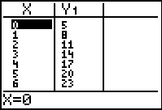
Using the tables:
1. Press 2nd GRAPH to get to the TABLE, you should be able to view the values for x and Y₁ now:

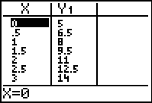
2. Sometimes you want to view exact values for number other than the integers. For example, if a question asks you what is the value of y when x=1/2 then you could not get the answer from this table. To change the table, go to 2nd WINDOW, for TBLSET, and change the TblStart value to 0 (or whatever value you want to start at) and then change your ΔTbl to a different increment, for example, to 0.5. This will make the x-values in your table go by .5 instead of by 1.
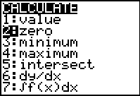
Finding the x-intercept:
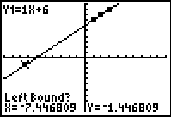
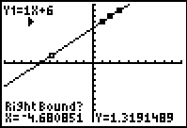
1. To find the x-intercept of any graph while you are viewing the graph: Press ZOOM, then 6, then ENTER, for a standard screen. Now press 2nd TRACE (for CALC). Press the number 2 for ZERO. Now arrow over until your cursor is to the left of the x-intercept and press ENTER. Now arrow over until your cursor is to the right of the x-intercept and press ENTER. Press ENTER again and your x-intercept should appear at the bottom of the screen.

