Running a Simulation Using Microsoft Excel

- To generate the results of the simulation:
  - Open a new Excel spreadsheet.
  - Enter a heading at the top of a column, if desired.
  - Under “Tools” click on “Data Analysis.”
  - Find “Random Number Generation,” and double-click on it or highlight it and click OK.
- Here are some examples of simulations:
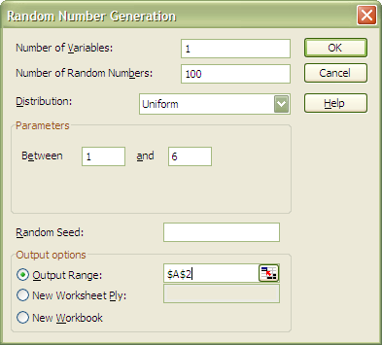
  - To simulate rolling a six-sided die 100 times
A2 – A101 will hold the results.

  - To simulate 500 at-bats for a baseball player with a 0.320 batting average.
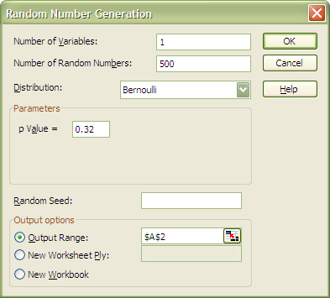
A2 – A501 will hold the results.
A result of 1 means a hit, 0 means an out.

  - To simulate a basketball player with a 70% free-throw average shooting ten free throws, 1000 times.
C2 – C1001 will hold the results.
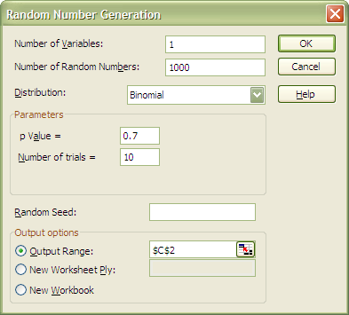
The result in each row is the number of made
free throws (0 – 10) out of 10 attempts.

  - To simulate rolling two six-sided dice and recording the sum 250 times. 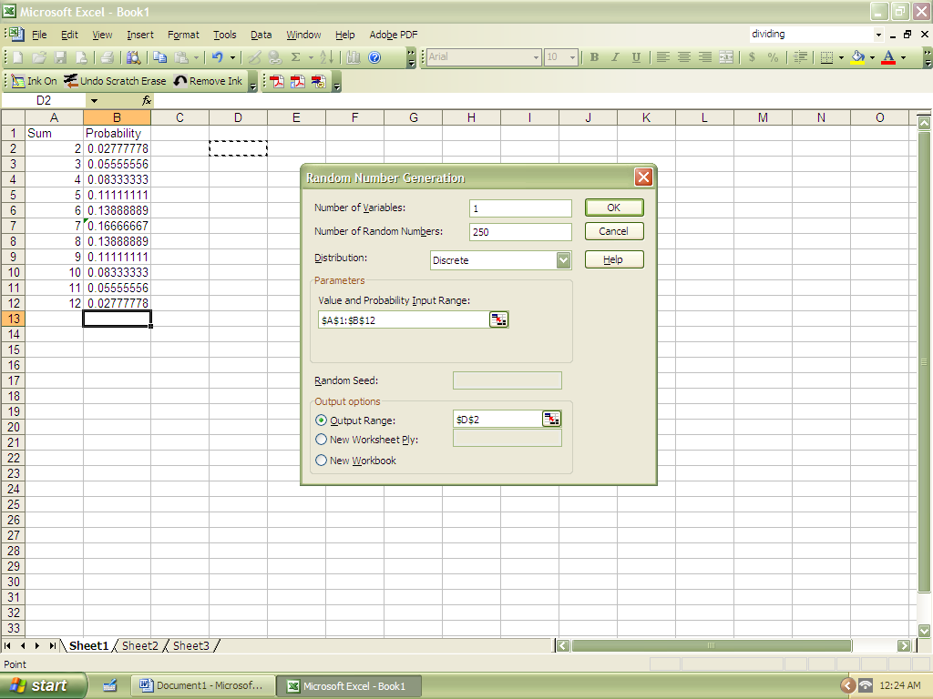
- To tally the results in a table and create a histogram from the table:
  - Under tools click on “Data Analysis.”
  - Find “Histogram,” and double-click or highlight and click OK.
  - 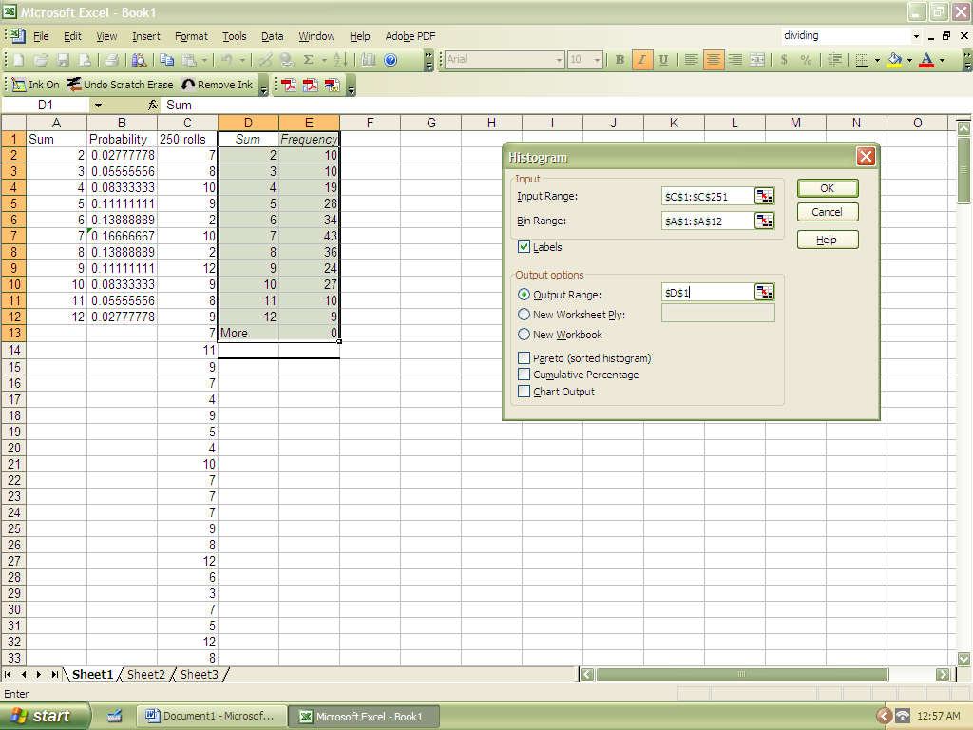
  - Leave the table created by “Histogram” highlighted and click on the Chart Wizard icon. You may simply click “Next” all the way through the wizard, unless you want to change or add something.
  - 