A POV-Ray “Holodeck”
Carl Lee

Download the file holodeck.pov from the institute website www.ms.uky.edu/~lee/amsptech/amsptech.html.

Open and render it with POV-Ray to see a few shapes:

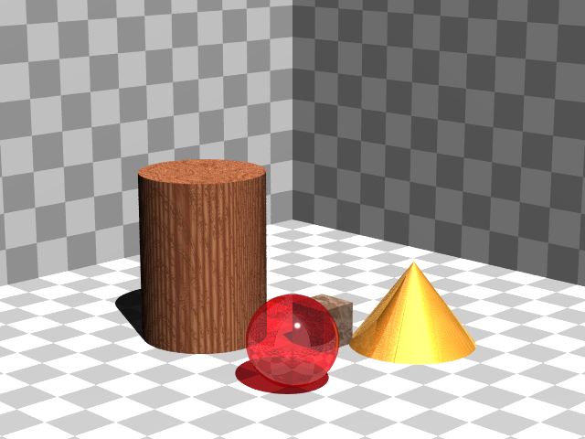

Now design your own scene by doing the following. Take a square piece of grid paper (e.g., centimeter grid paper):

Cut out the upper left-hand quarter of it:

Fold it up to make a “room” with a floor and two walls. The creased correspond to the three x-, y-, and z-axes. (I have not drawn all the gridlines in the figure below.)

You can place shapes into it (such as spheres, boxes, cones, and cylinders) and determine measurements (such as radii, coordinates of particular points) to specify the locations of the objects. You can then use this information to draw the shapes within POV-Ray. Try changing the specifications of the shapes at the very bottom of the POV-Ray file. You may also want to try changing the location of the camera and the light source. Try different textures as well. For example, try

T_Stone1 through T_Stone44
T_Wood1 through T_Wood35
T_Brass_1A through T_Brass_5E and the same for Copper, Chrome, Silver, and Gold
T_Glass1, T_Glass2, T_Glass3, T_Glass4, T_Old_Glass, T_Winebottle_Glass, T_Beerbottle_Glass, T_Ruby_Glass, T_Green_Glass, T_Dark_Green_Glass, T_Yellow_Glass, T_Orange_Glass, T_Vicksbottle_Glass

POV-Ray can also display geometric unions, intersections, and differences. See, for example, holodeck2.pov.

