Stereographic Projection

Honors 301
Professor Lee
6 April 2005
Graham Barth

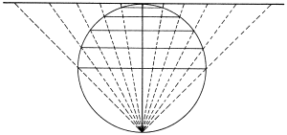
Stereographic Projection

Mapmaking has existed on planet Earth for thousands of years. From the ancient Greeks with their intimate knowledge of the Mediterranean Sea to modern data that can chart every border imaginable with great precision, it has been an interesting and useful tool to project the components of a three-dimensional sphere onto a two-dimensional plane. This projection has allowed humans to set country borders, navigate oceans and rivers, and provide effective and accurate ways to understand direction. It is the job of the geographer to come up with methods of constructing these maps, and stereographic projection is one of the best ones to utilize.
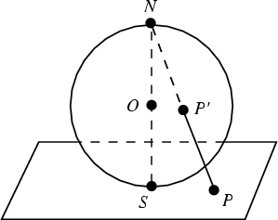
The easiest way to think about stereographic projection is by imagining a transparent sphere resting on an opaque surface, such as a piece of paper or the top of a table. A light is introduced at the northern pole, and is pointed directly downward, forming a circle of a large radius around the sphere. Each ray of light is a straight line going through one point on the sphere and down to the surface. One would imagine that if a solid object is placed anywhere on the sphere, it would cause a shadow to appear on the plane. The shadow would not necessarily represent an exact duplicate of the object, because it could be longer or shorter, but it is the projection of the object from the three-dimensional sphere to the two-dimensional plane. Obviously, at the southern pole, the shadow would most represent its object counterpart, and towards the equator it would become more skewed. Overall, if one were to take the sphere and peel it like an orange, laying it flat, the result would be a relatively accurate projection on a plane.
If, for example, a series of horizontal rings of varying radii were placed around the sphere, one would expect to see small rings near the southern pole that get larger as they go outward, like the rings of a tree. The farther they go out, the more like horizontal lines they become. If this sphere is “rolled,” one would see this map of perfect circles become more and more skewed. The outermost circles would actually start to become straight lines, and the middle circles would take on the shape of ovals or ellipses from certain angles, with one side of the form very near to the sphere and the other side farther away. Even with a quick ninety-degree turn, the perfect circles would still be intact, but with the sphere residing near the edge instead of in the complete center. These shadows are not exactly like the rings surrounding the sphere, but they merely represent their two-dimensional projection at that particular angle. Since the light at the top of the sphere never changes position, it always pushes the same rays of light through the same points on the sphere. The only thing that changes is the position of the solid objects on the sphere relative to the plane. This is why different projections of the Earth look different when viewed at various angles.
Consider the example of the Earth. The South Pole would be a point at the exact center of the plane, right where it touches the Earth. The view of Antarctica would be very accurate, with almost no stretching of the borders, and it would become more and more distorted as you move out to the equator. The equator appears to be much larger than it actually is, twice to be exact, and things to the north of the equator, such as Greenland, are huge. The northern hemisphere is more distorted the farther up you go, and the point representing the North Pole goes off into infinity in all directions.¹ The most accurate projection will occur near the point where the sphere touches the plane.
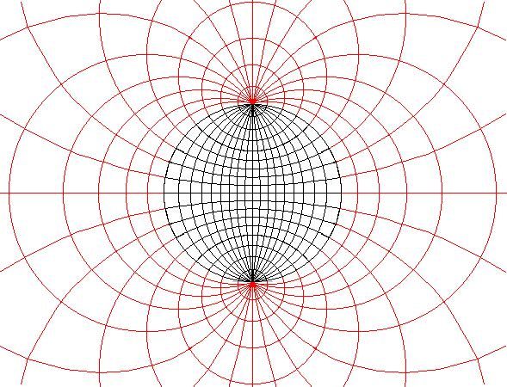In this figure, one can see that the more precise projection is the most concentrated one, or the points at the northern- and southernmost points on the sphere.
Every point on the sphere plots as a point on the plane, with the only exception being the northern pole of the sphere. This projection is conformal, meaning that angles and small shapes on the sphere project exactly as they are to the plane. No spherical projection allows the preservation of both area and shape, so there has to be some concessions made. Stereographic projection is conformal, but its tradeoff is that it has distortion as it retreats from the poles.² This is the only bad quality that it has. When small regions on the sphere are projected onto the plane, there is little to no distortion, though. This radial distortion only occurs as one moves away from the tangency point.³ It is possible to project the entire sphere onto one plane, with only the northern pole being absent. In theory this seems relevant, because it would allow one to see the entire object in one place without having to rotate it. But in practice, it is different. The distortion is too great as the farthest objects are reached for any practical utility. So, in the real world, stereographic projection is most commonly used for those points close to the tangency point.
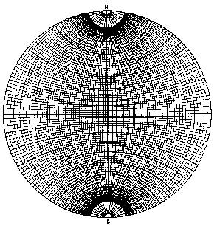
People use stereographic projection for different purposes. Mineralogists use what is called a Wulff stereonet, which is constructed using simple geometry. Structural geologists use a Schmidt stereonet, which is derived from a more complicated algorithm so that every square on the map is equal in area. The Wulff stereographic projection is constructed by projecting points from the sphere’s surface to the plane, just like what was mentioned above. The only difference is that the plane cuts through the center of the sphere in the Wulff model. Each point from the upper hemisphere is plotted onto the plane, exactly where the line of projection passes through the plane of projection.⁴ If one were to plot the southern hemisphere, it would be inverted when the northern pole is used as the point of projection. The Schmidt projections usually represent the southern hemisphere.
The stereonet, or the system of longitudinal and latitudinal lines encompassing a sphere, shows the projection of numerous great circles and small circles. A great circle has its radius equal to that of the entire sphere. It usually cuts through the equatorial plane and splits the sphere in half. A small circle is any circle with radius less than that of the whole sphere. A good way to imagine a small circle is to think of a point on the sphere, and to imagine the sphere rotating on an axis which is not far from the point. The path that the point takes along the sphere represents a small circle.⁵ The longitudinal lines of the earth are great circles, because they all go through both the North and South Poles. They are each equal to the equator, and if they were represented as planes, they would pass directly through the center of the earth. The latitudinal lines, on the other hand, are small circles, except for the equator. All of the lines above and below the equator wane in radius.
When one first sees an illuminated, transparent ball with some rings around it, rolling around on a plane, the mathematical and genuine significance might escape the person. After all, it’s just shadows from the light, right? That’s simple enough. But the implications of this phenomenon are much greater than they appear. Since every single point on the sphere (except the northern pole) is extended and represented on the plane, it is possible to see nearly the entire sphere in one two-dimensional picture. No rotation is necessary. This greatly raises our ability to understand maps and to discover the sizes of different objects relative to their place on the projection. Stereographic projection is a useful tool in geometry, but it also has been used for hundreds of years by mineralogists and cartographers alike. If it weren’t for stereographic projection, our modern maps would not be nearly as effective or accurate as they are. This type of projection allows us to understand where certain countries are in relation to others, as well as providing the simplicity of seeing almost the entire planet on a two-dimensional plane. This only proves that stereographic projection is a mathematical formula but has valid and real-world applications. It is only when you get past the first glance that you realize it is more than just a ball rolling on a plane.
References

(1) Banchoff, Thomas F. Beyond the Third Dimension. Scientific American Library. New York, NY, 1990. pp. 124-126

(2) Dutch, Steven. “Spherical Projections.” From University of Wisconsin – Green Bay Website. http://www.uwgb.edu/dutchs/structge/sphproj.htm

(3) ibid.

(4) “Mineralogy – Stereographic Projections” http://www.science.smith.edu/departments/Geology/Min_jb/StereoProjs.pdf

(5) ibid.

